Highgate Opera Circle January-March 2020 Season Review

15 January 2020  Agrippina  (Following Annual Meeting)  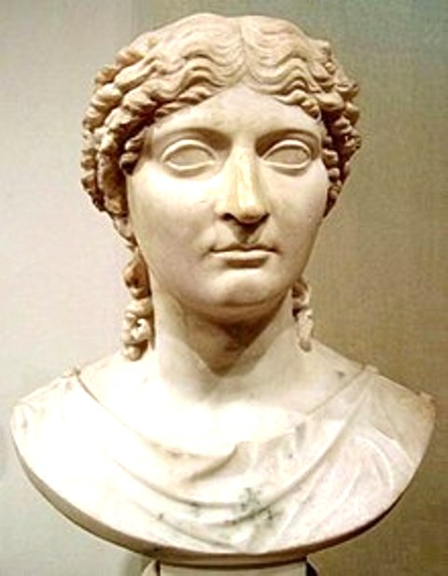  Handel’s first operatic masterpiece written for Venice in 1710 |  | 12 February 2020  The Flying Dutchman  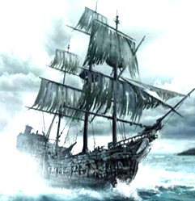  Wagner’s music drama of the cursed sea captain doomed to sail the oceans until he can find redemption through womanly love |  | 11 March 2020  Fidelio  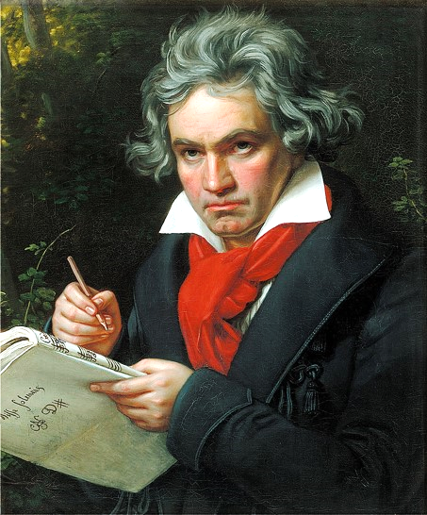  An evening on Beethoven’s only opera creating an overwhelming experience of freedom from tyranny

The Opera Circle has had a very successful Spring season with average audiences of 60 for each of the 3 evenings.
In January baroque enthusiast Brian Hargreaves introduced us to Handel’s anti heroic satirical opera Agrippina. For most of us the highlight of the evening was a clip from Joyce DiDonato singing the title role, which she was performing in new productions both at Covent Garden and the Met.
In February Barry Mellor introduced us to several wonderful recordings of Wagner’s Flying Dutchman, all of which had some great singing in productions that brought out all the drama of the raging seas.
In March Anne Casson compared some very moving productions of Fidelio as an introduction to the future performances at Covent Garden. For some, a clip showing Jon Vickers as Florestan in the dungeon scene has never been surpassed. Fortunately, a Covent Garden performance was recorded just before lockdown and subsequently shown on BBC4, without Jonas Kaufmann, but with the wonderful Norwegian soprano Lise Davidson taking the part of Leonore (Fidelio).
Sadly, then lockdown intervened and we have been unable to continue with any further Opera Circle evenings.
We are of course regularly reviewing our future plans and will reconvene as soon as is practical and appropriate to continue to bring you the highest quality performances in HD sound and vision. We expect this to be in the New Year. In the meantime, keep well and enjoy all the daily live streaming from the Met and from all round the world!
Geoff Hunt
April 2020

