Highgate Opera Circle January-June 2021 Zoom Season Review
I am very pleased to say that after the cancellation of activities, because of the pandemic, from May last year, the Opera Circle has now recommenced, albeit on Zoom, in 2021.
The first event in January was a One-to-One interview, but because two members of the Opera committee were talking to each other and the format was changed to Desert Island Discs, I have included it here. Michael de Swiet was asking Geoff Hunt (Opera Circle chair) about his operatic choice for the desert island. Geoff chose video extracts to include 3 of his favourite singers, Tito Gobbi, Jon Vickers and Mirella Freni. His favourite opera was between Berlioz’s The Trojans and Verdi’s Don Carlos, but because the Verdi brought back so many memories with the great singers, this was his first choice. A very successful occasion with over 100 in attendance.
The first official Opera Circle event in February took the form of an Opera quiz; identifying operas associated with the moon, including a presentation by Ross Alley, three questions from University Challenge, and ending with some opera cats. The evening was a great success with plenty of good music and much enjoyment was had by all in a very relaxed fun atmosphere.
We will now move on to those postponed events from last year
In March we had a fascinating evening on Grand Opera in Paris, which flourished there in the mid-19th century. This was presented by HGO Chairman David Conway. Geoff Hunt introduced David by way of Sherlock Holmes, who also enjoyed French Grand Opera, in particular Meyerbeer’s Les Huguenots.

4.00pm 31 January 2021  Geoff Hunt’s  Desert Island Discs  with Michael de Swiet  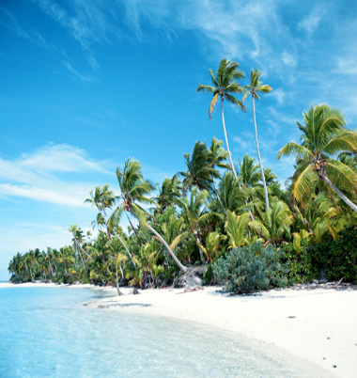  One-to-One interview |  | 7.30 pm 10 February 2021  Opera Circle Quiz  Presented by Geoff Hunt  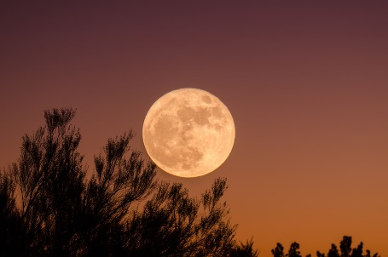  How many operas can you associate with the moon?  With rounds on University Challenge and Opera cats, it’s just a bit of fun! |  | 7.30 pm 17 March 2021  Grand Opera in Paris  Presented by HGO Chairman  David Conway  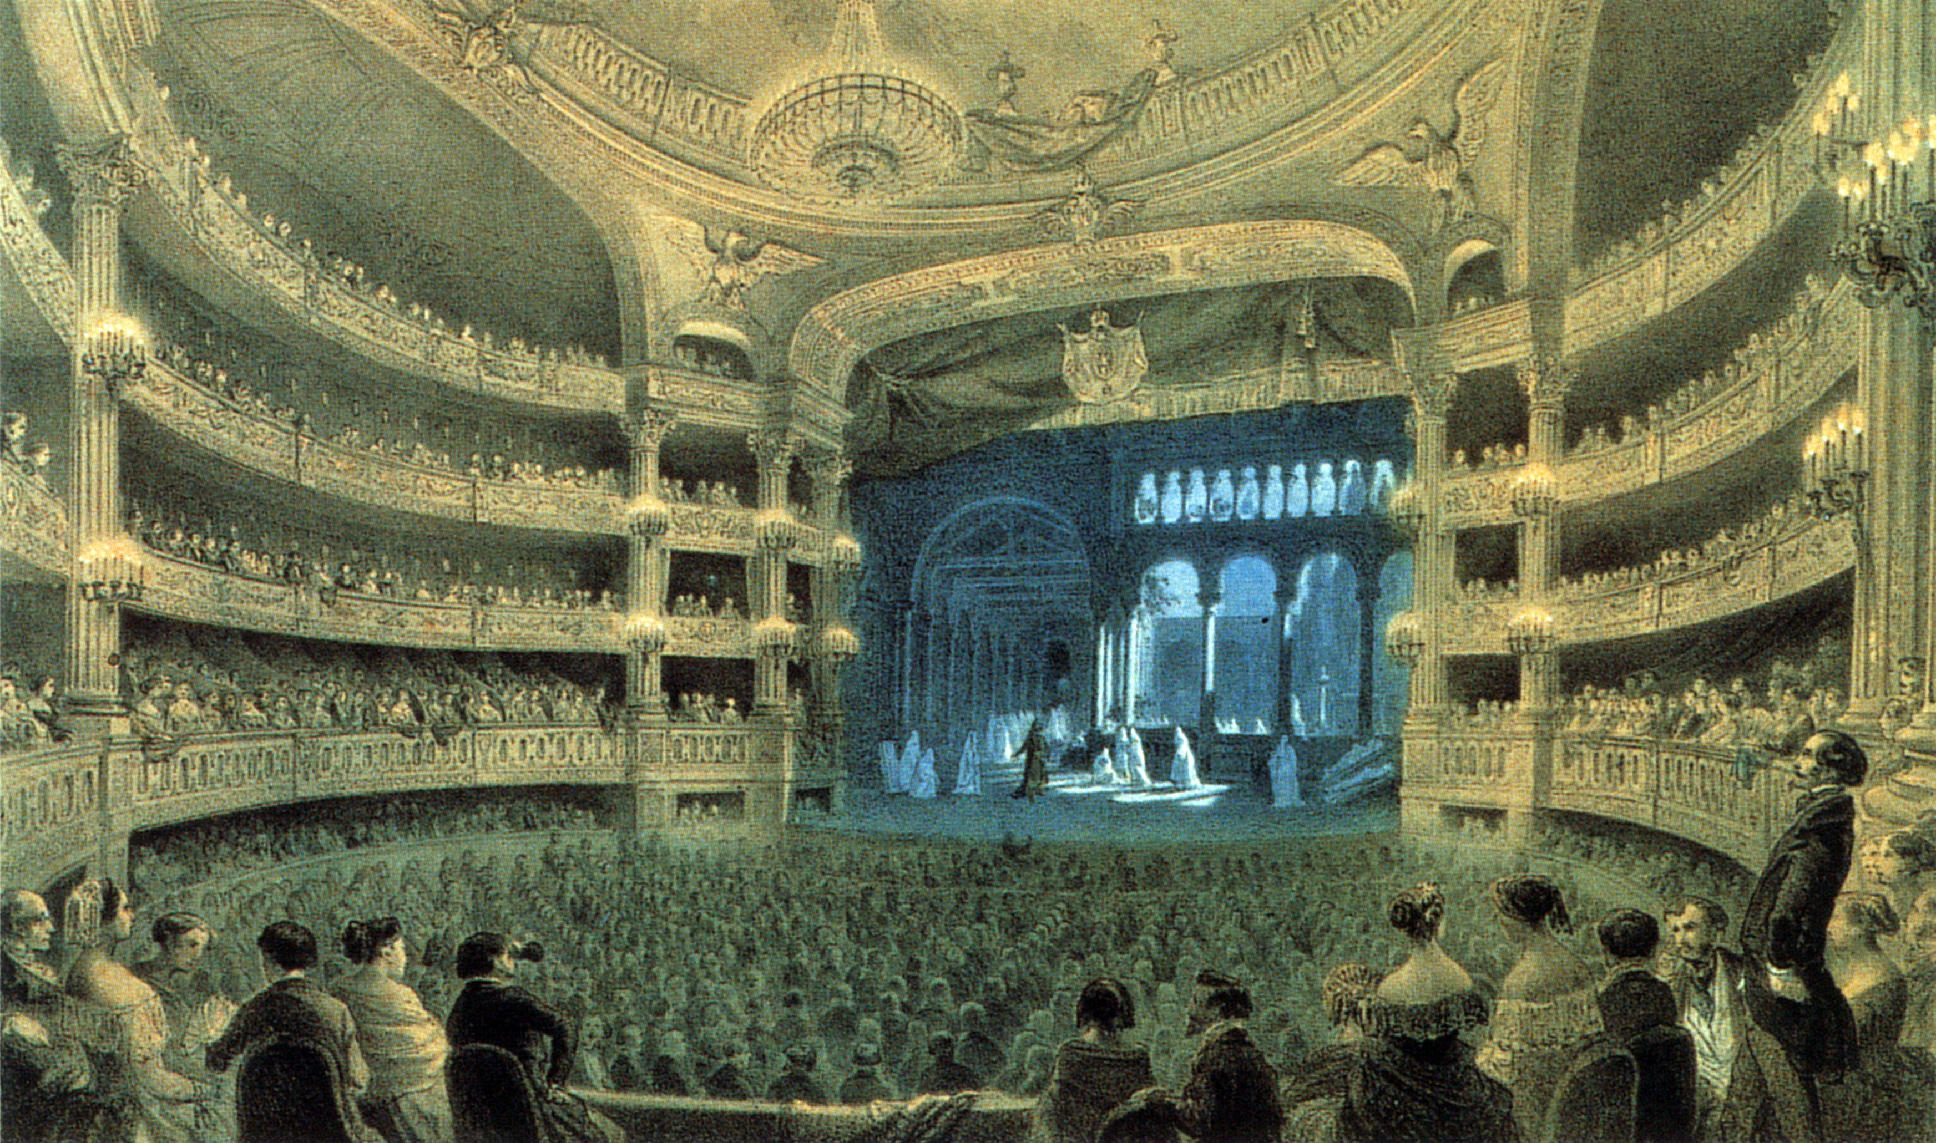  An evening on the now rarely performed operas of Meyerbeer, Halévy and others, which flourished in mid-19th century Paris.
In May, opera singer Penny Chalmers joined us to present an evening on Strauss’s Elektra. By way of introduction Isabel Raphael presented Elektra from a classical perspective.
In June Brian Hargreaves took us into the world of Vivaldi and his wonderful baroque operas.
Many thanks to all our contributors, including Monica Leighton who hosts all our Zoom evenings.
7.30pm 5 May 2021  Elektra  Presented by Penny Chalmers  with a classical perspective from Isabel Raphael  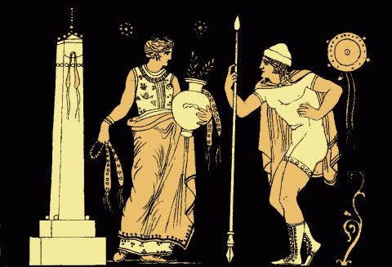  An evening on Richard Strauss’s opera after the tragedy by Sophocles |  | 7.30pm 9 June 2021  Beyond the Four Seasons.  Exploring the other side of Vivaldi  Presented by Brian Hargreaves  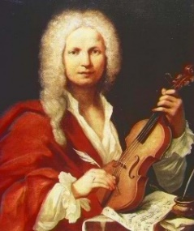  Enjoy some of the most beautiful  and exciting vocal music in Baroque Opera!
The Opera Circle will recommence after the summer break in October, when hopefully we will be able to resume in the Victoria Hall with wide screen and Hi-fi sound!
Geoff Hunt
June 2021

