Highgate Opera Circle 2021/22 Zoom Season Review
During the Covid 19 pandemic the Opera Circle has been operating on Zoom and maintaining average audience levels at around 60 across the evenings, with the less popular operas generating slightly lower audience numbers, but offset by greater audiences from the more familiar favourites. Any extra audience generated on Zoom outside the Highgate area, or those wary of Covid, broadly offset the loss of those who struggled with the technology.
The 2021/22 Opera Circle season opened in October profiling HGO’s new production of the Marriage of Figaro at Jackson’s Lane. In the first half Bill English introduced the opera, playing clips from 3 classic recordings: The Ponelle film of 1975 with Mirella Freni, Dietrich Fischer-Dieskau and Herman Prey. Jonathan Miller introducing his production at the Met in 1998 with Renee Fleming, Cecelia Bartoli and Bryn Terfel. Gerald Finley in David McVicar’s current 2006 production from Covent Garden. After the interval, HGO’s director introduced her approach to the opera and the new production concepts.
In November, Bill English then introduced us to one of his enthusiasms, Russian Opera, when he provided a fascinating history and played excerpts from the operas of Glinka (including Ruslan and Lyudmila (1842) sounding in part like Bellini when sung by Anna Netrbko!), Borodin, Mussorgsky and Rimsky Korsakov. There was also an introduction to Russian folk culture by Faith Wigzell, emeritus professor at UCL.
In December, Geoff Hunt gave us a delightful pre-Christmas evening, celebrating Donizetti’s great comic opera L’Elisir d’Amore in some classic performances. Angela Gheorghiu and Roberto Alagna in 1996 from Lyon, and Rolando Villazon and Anna Netrebko in 2005 from Vienna. The evening also included two of the great baritones of the period, Tito Gobbi as Sergeant Belcore in a film from 1947, and ending with a rare clip of Geraint Evans as Duclamara in his Covent Garden farewell in 1994.
In January, were very pleased to welcome the return of Brian Hargreaves profiling two forthcoming operas never previously performed at Covent Garden; Vivaldi’s Bajazet of 1735, and Handel’s masterpiece Theodora of 1750. This was a great introduction from Brian, with some of the best singers of the day, including Elina Garanca in the Vivaldi, and the unsurpassed Lorraine Hunt Lieberson in the classic recording of Theodora from Glyndebourne in 1996.
In February, we were very privileged to welcome the return of soprano Penny Chalmers, recounting performing one of her favourite roles, the 300-year-old Emilia Marty in Janacek’s The Makropulos Case. It was wonderful to hear all the great singers in the role including Karita Mattila, Anja Silja and perhaps the finest of them all Elisabeth Soderstrom poignantly deciding that 300 years of life was enough.
In March, Geoff Hunt profiled John Blow’s Venus and Adonis (1684) and Purcell’s Dido and Aeneas (1689) as an introduction to HGO’s forthcoming new production in May. Geoff provided a comprehensive background to the lives and the historical context of both composers, including their work in the Chapel Royal. The musical highlight was a rare video clip of Janet Baker singing When I am laid in Earth from a telecast of 1966. After the interval, HGO’s producer and music director then gave their very interesting introductions and perspectives to the forthcoming production.
After the April holiday break, the 8 June Opera Circle evening had to be cancelled, as it clashed with a Music Appreciation opera study day on the Ring. Turandot was therefore now replaced with Samson & Dalila on 4 May, when Geoff Hunt profiled the opera, particularly in relation to the great tenor Jon Vickers, ahead of the first new Covent Garden production since 1981.
Barry Mellor’s evening exploring beyond Nessun Dorma in Puccini’s Turandot, will now open the Opera Circle season for 2022/23, and will be celebrating the return to the Victoria Hall on 5 October.
Geoff Hunt May 2022

Highgate Opera Circle  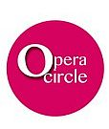  2021-22 Zoom Season |  | 6 October 2021  Marriage of Figaro  Presented by the Bill English and HGO  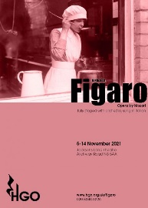  An evening profiling the opera and HGO’s  new production |  | 3 November 2021  Highlights of Russian Opera  Presented by Bill English  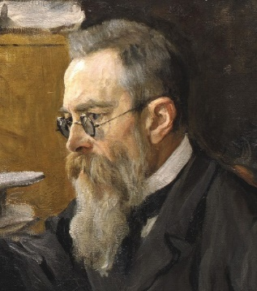  An evening with some  masterpieces of Russian opera
1 December 2021  L’Elisir d’Amore  Presented by Geoff Hunt  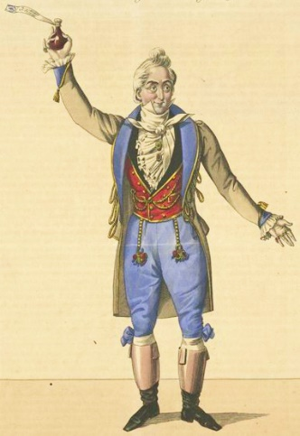  An evening on Donizetti’s comic masterpiece |  | 12 January 2022  Handel Theodora  Vivaldi Bajazet  Presented by Brian Hargreaves  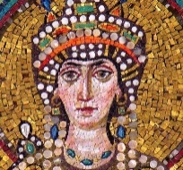  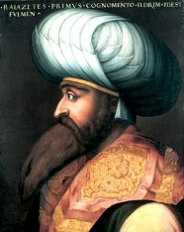  Two ignored and unknown Baroque gems |  | 9 February 2022  The Makropulos Case  Presented by Penny Chalmers  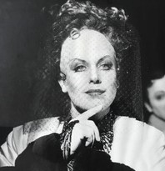  Penny Chalmers as the 300 year-old Emilia Marty  Janacek’s powerful and extraordinary  Czech opera mystery
9 March 2022  Purcell Dido & Aeneas  Blow Venus & Adonis Presented by Geoff Hunt  and HGO  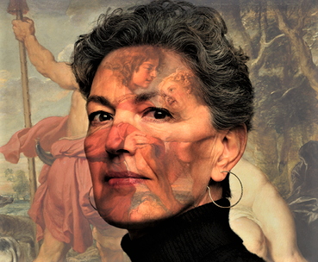  An evening profiling the operas and HGO’s forthcoming new production |  | 4 May 2022  Samson & Dalila  Presented by Geoff Hunt  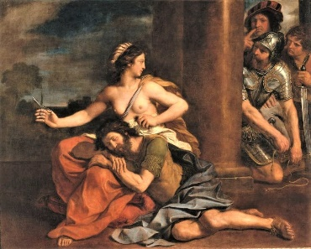  An evening of Saint-Saen’s glorious music including Jon Vickers in one of his greatest roles

